Lab7 Notes

Exerc. 1: user_profiles_to_datalake.json has the code for the data flow.

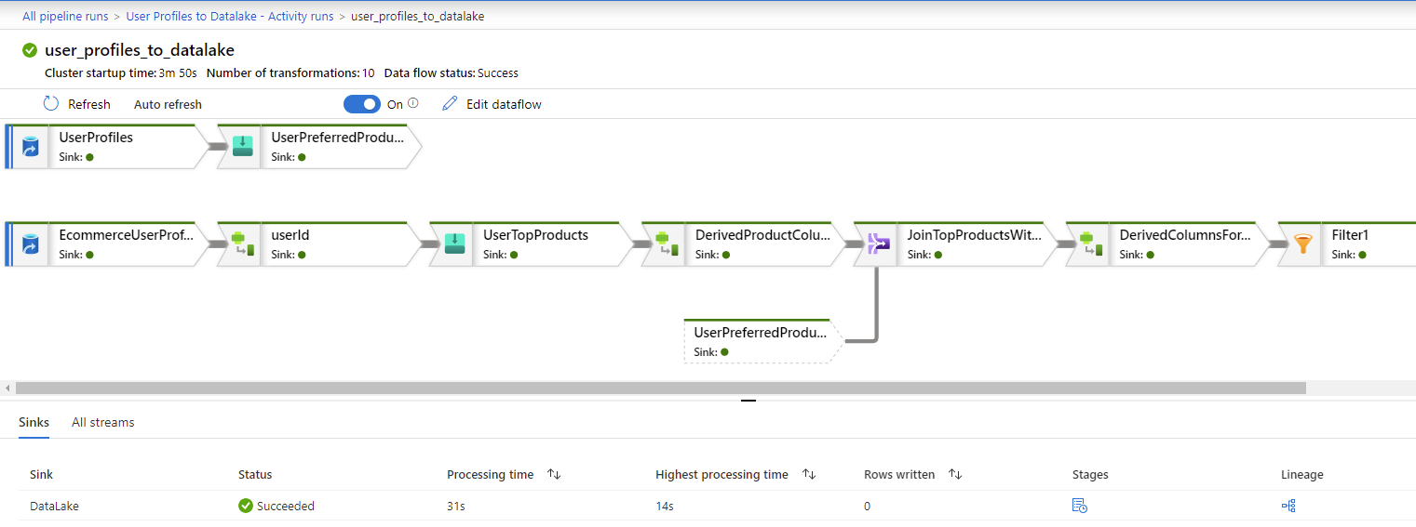

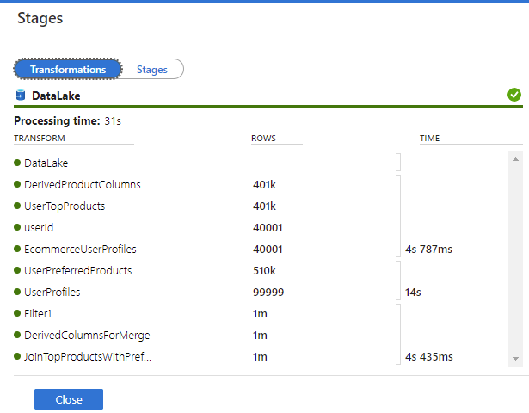

Exerc. 2 : Calculate Top 5 Products.ipynb

